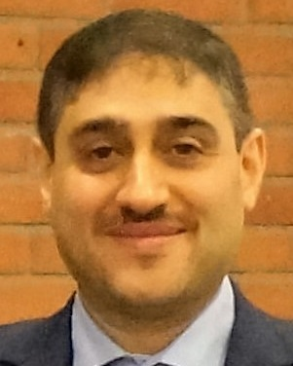
Name: Anas Wasill Al-Hashimi
Research Name: Anas W. Alhashimi
Official email: anas.alhashimi@coeng.uobaghdad.edu.iq
Scientific degniversity Teacher
Published papers:
- 2018 Anas W. Alhashimi, Simone Del Favero, Damiano Varagnolo, Thomas Gustafsson, and Gianluigi Pillonetto. Bayesian strategies for calibrating heteroskedastic static sensors with unknown model structures. In European Control Conference (ECC), 2018.
- 2017 Anas W. Alhashimi, Damiano Varagnolo, and Thomas Gustafsson. Calibrating distance sensors for terrestrial applications without groundtruth information. IEEE Sensors Journal, 17(12):3698–3709, 2017.
- 2016 Anas W. Alhashimi, Damiano Varagnolo, and Thomas Gustafsson. Statistical modeling and calibration of triangulation lidars. In Informatics in Control, Automation and Robotics (ICINCO), 13th International Conference on, pages 308–317, 2016.
- 2015 Anas W. Alhashimi, Damiano Varagnolo, and Thomas Gustafsson. Joint temperature-lasing mode compensation for time-of-flight lidar sensors. Sensors, 15(12):31205– 31223, 2015.
- 2014 Anas W. Alhashimi, Roland Hostettler, and Thomas Gustafsson. An improvement in the observation model for monte carlo localization. In Informatics in Control, Automation and Robotics (ICINCO), 11th International Conference on, volume 2, pages 498–505. IEEE, 2014.
- 2012 Anas W. Alhashimi. The application of autoregressive spectrum modeling for identification of the intercepted radar signal frequency modulation. Inventi Impact: Telecom, 12(Article ID- " Inventi:etc/36/12 "), 2012.
- 2011 Anas W. Alhashimi. Design and implementation of fast three stages sla battery charger for plc systems. Journal of Engineering, 17(3):448–465, 2011.
- 2007 Anas W. Alhashimi and SN Abdullah. Deinterleaving of radar signals and prf identification algorithms. IET radar, sonar & navigation, 1(5):340–347, 2007.
Research trends:
- Laser range finder Lidar for robotic applications
- Statistical sensor modeling and calibration
- Parameter estimation and model order selection under variable noise variance (heteroscedasticity)
- system identification
- Joint parameters and state estimation
- Monte Carlo methods
- Robot Localization and Mapping
- Robot Navigation and path-planning
Published books:
2018 Anas W. Alhashimi, Giovanni Pierobon, Damiano Varagnolo, and Thomas Gustafsson. Modeling and calibrating triangulation lidars for indoor applications. In Informatics in Control, Automation and Robotics, pages 342–366. Springer, Cham, 2018. (book chapter)
MSc theses supervised:
2016-2017 “Calibrating lidars in structured environments” by: Giovanni Pierobon, Supervisors: Damiano Varagnolo, Anas Alhashimi and Ruggero Carli, Department of Information Engineering, University of Padova, Italy.
PhD dissertations supervised:
-

