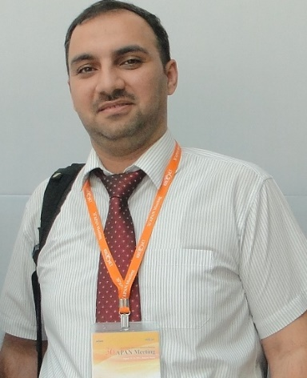

الاسم الثلاثي: مصطفى اسماعيل سلمان

Scholar Name | Mustafa Ismael Salman
Official E-mail | mustafa.i.s@coeng.uobaghdad.edu.iq
Scientific Degree | PhD, Lecturer
Published Articles | Published Journal Papers  1. Salman, Mustafa Ismael, Chee Kyun Ng, Nor Kamariah Noordin, Borhanuddin Mohd Ali, and Aduwati Sali. "A self-configured link adaptation for green LTE downlinks transmission." Published in Transactions on Emerging Telecommunications Technologies (2014) (x-title: European transactions on telecommunications). Impact Factor JCR-2013: 1.354  2. Salman, Mustafa Ismael, Muntadher Qasim Abdulhasan, Chee Kyun Ng, Nor Kamariah Noordin, Aduwati Sali, and Borhanuddin Mohd Ali. "Radio Resource Management for Green 3GPP Long Term Evolution Cellular Networks: Review and Trade-offs." Published in IETE Technical Review Vol. 30, no. 3 (2013). Impact Factor JCR-2013: 0.925  3. Abdulhasan, Muntadher Qasim, Mustafa Ismael Salman, Chee Kyun Ng, Nor Kamariah Noordin, Shaiful Jahari Hashim, and Fazirulhisham Hashim. "Review of Channel Quality Indicator Estimation Schemes for Multi-User MIMO in 3GPP LTE/LTE-A Systems." Published in KSII Transactions on Internet & Information Systems 8, no. 6 (2014). Impact Factor JCR-2013: 0.345  4. Abdulhasan, Muntadher Qasim, Mustafa Ismael Salman, Chee Kyun Ng, Nor Kamariah Noordin, Shaiful Jahari Hashim, and Fazirulhisham Hashim. "An Adaptive Threshold Feedback Compression Scheme Based on Channel Quality Indicator (CQI) in Long Term Evolution (LTE) System." Published in Wireless Personal Communications (2015): 1-27. Impact Factor JCR-2013: 0.979  5. Salman, Mustafa Ismael, Chee Kyun Ng, Nor Kamariah Noordin, Borhanuddin Mohd Ali, and Aduwati Sali. " A Partial Feedback Reporting Scheme for LTE Video Transmission with Guaranteed QoS ". Accepted in Computer Networks, Impact Factor JCR-2013: 1.4  6. Salman, Mustafa Ismael, Chee Kyun Ng, Nor Kamariah Noordin, Borhanuddin Mohd Ali, and Aduwati Sali. "Energy efficient transmission for LTE cellular system." In Computer and Communication Engineering (ICCCE), Malaysia, 2012 International Conference on, pp. 222-227. IEEE, 2012.  7. Salman, Mustafa Ismael, Chee Kyun Ng, Nor Kamariah Noordin, Borhanuddin Mohd Ali, and Aduwati Sati. "CQI-MCS Mapping for Green LTE Downlink Transmission." Proceedings of the Asia-Pacific Advanced Network 36, Korea (2013): 74-82.  8. Salman, Mustafa Ismael, Chee Kyun Ng, and Nor Kamariah Noordin. "Energy-and Spectral-Efficient Wireless Cellular Networks." Proceedings of the Green Communications and Networking, GreenNets, colmar, France, 2011. http://greenets.org/2011/index.shtml.  9 Salman, Mustafa Ismael, Muntadher Q. Abdulhasan, Chee Kyun Ng, Nor Kamariah Noordin, Borhanuddin Mohd Ali, and Aduwati Sati. “Adaptive Threshold CQI Compression Scheme for LTE cellular Systems ." Proceedings of the Asia-Pacific Advanced Network 40, Malaysia (2015).  10. Abdulhasan, Muntadher Qasim, Mustafa Ismael Salman, Chee Kyun Ng, Nor Kamariah Noordin, Shaiful Jahari Hashim, and Fazirulhisham Bin Hashim. "Approximate Linear Minimum Mean Square Error estimation based on Channel Quality Indicator feedback in LTE systems." In Communications (MICC), 2013 IEEE Malaysia International Conference on, pp. 446-451. IEEE, 2013.  11 Abdulhasan, MQ., Salman, Mustafa Ismael., Ng, CK., Noordin, NK., Shaiful, JH., Fazirulhisham, BH., “A Threshold Feedback Compression Scheme of Channel Quality Indicator (CQI) in LTE Systems, ”, 2013 IEEE Student Conference on Research & Development(SCOReD).  12. Thian, L. L., Ali M. Al-Saegh, K. F. Ramli, N. S. Ibrahim, A. Sali, and Mustafa Ismael Salman. "Energy-driven scheduling for Digital Video Broadcasting-Satellite Second Generation (DVB-S2)." In Space Science and Communication (IconSpace), 2013 IEEE International Conference on, pp. 385-390. IEEE, 2013.
Research Areas | LTE, OFDMA, Resource Allocation, Green Radio and SDN
Published Books | N/A
Master Degree Supervision | 2
Doctoral Degree Supervision | N/A

