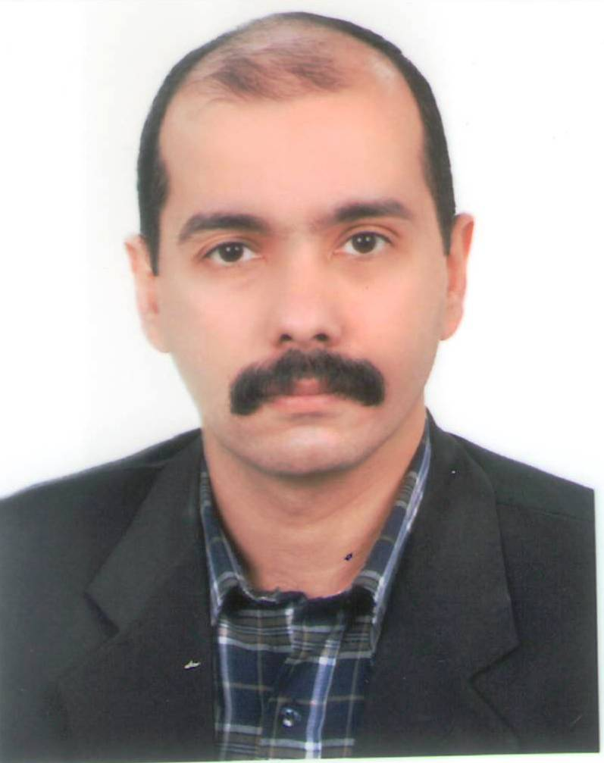

Name: Omar Waleed Abdulwahhab
Research Name: Omar Waleed Abdulwahhab
Official email: omar.waleed@uobaghdad.coeng.edu.iq
Scientific degree: Assistant professor
Published papers:
- A New Analytic Method to Tune a Fractional Order PID Controller
- A New Analytic Method to Tune a Fractional Order PID Controller
- A new method to tune a fractional-order pid controller for a twin rotor aerodynamic system
- A New Method to Tune a Fractional-Order PID Controller for a Twin Rotor Aerodynamic System
- Adding PC Connectivity to the MTS-88 Microcomputer Teaching System.
- Design and Stability Analysis of a Fractional Order State Feedback Controller for Trajectory Tracking of a Differential Drive Robot
- Design of a Fractional Order Sliding Mode Controller for Twin Rotor Aerodynamic System
- Design of a Variable Gain Nonlinear Fuzzy Controller and Performance Enhancement Due To Gain Variation
- Enhancing the Delta Training Rule for a Single Layer Feedforward Heteroassociative Memory Neural Network
- Fuzzy Controllers for Single Point Controller-1 (SPC-1) Systems
- Mobile Position Estimation based on Three Angles of Arrival using an Interpolative Neural Network
- Mobile Position Estimation using Artificial Neural Network in CDMA Cellular Systems
- Organization of Memory Chips In Memory Systems That Have Word Size Wider Than 8-Bit
- Self-Organizing Fuzzy Controller for A Non-Linear Time Varying System
- Using Fuzzy Logic Controller for a Two- Tank Level Control System

Research trends:
- Control theory
- Control applications
- Soft computing

Published books: -
MSc theses supervised: -
PhD dissertations supervised: -

