Maysoon Basheer Abid | الاسم المستخدم لنشرالبحوث حسب الكوكل سكولر
maysoon.basheer @coeng.uobaghdad.edu.iq | الايميل الرسمي
مدرس دكتور | الدرجة العلمية
- Two-Dimensional Unsteady Dispersion of Pollutants at Hindiya Station on Euphrates River. Stations  - Analytical Solution of Unsaturated Soil Water Flow from a Point Source.  - Numerical Simulation of Unsaturated Flow in Porous Media Using the Finite Volume Method.  - Numerical Simulation of Two-Dimensional Unsaturated Flow from a Trickle Irrigation Source using the Finite Volume Method.  - .Numerical Modeling of Water Movement from Buried Vertical Ceramic Pipes through Coarse Soils.  - Numerical Modeling of Water Movement from Buried Vertical Ceramic Pipes through Soils.  - Numerical Simulation of Water Flow through Soil from a Trickle Irrigation with Water Uptake by Roots  - Numerical Simulation of Unsaturated Soil Water from a Trickle Irrigation System for Sandy Loam Soils  - Examiner for different Master degree thesis (2013-2018)  - Evaluation some of the research papers (2012-2018) | البحوث المنشورة
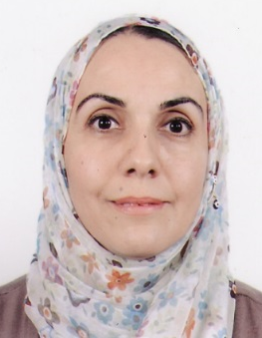 | الاسم الثلاثي واللقب  ميسون بشير عبد

Irrigation Systems, Computational Fluid Dynamics | الاتجامهات البحثية
لا يوجد | كتب ومؤلفات
اربعة | رسائل الماجستير التي اشرف عليها
لايوجد | اطاريح الدكتوراة التي اشرف عليها

