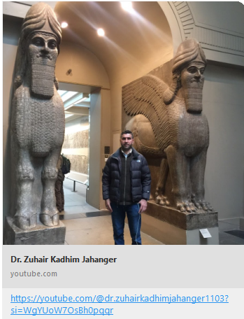
https://youtube.com/@dr.zuhairkadhimjahanger1103?si=WgYUoW7OsBh0pqqr

https://youtube.com/@hussainfadhil?si=qzaTskyIJlqpVlVB
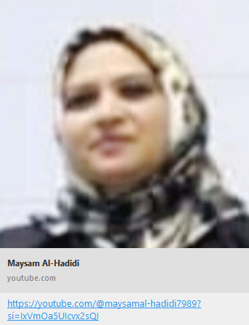
https://youtube.com/@maysamal-hadidi7989?si=IxVmOa5UIcvx2sQI

روابط
محاضرات
للصفوف الالكترونية

https://classroom.google.com/c/NTY5Mjg3MzU0Njk4
https://classroom.google.com/c/NDkxMjQ3Mjk4NzUz

https://classroom.google.com/c/NTU3MDAyMjUxNjE5

